SCREENSHOT OF THE WEBSITE...

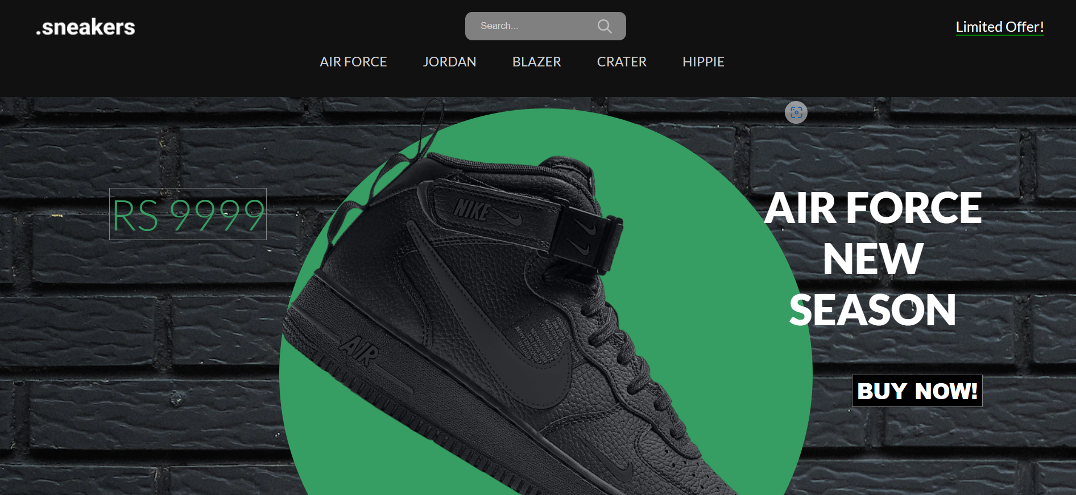

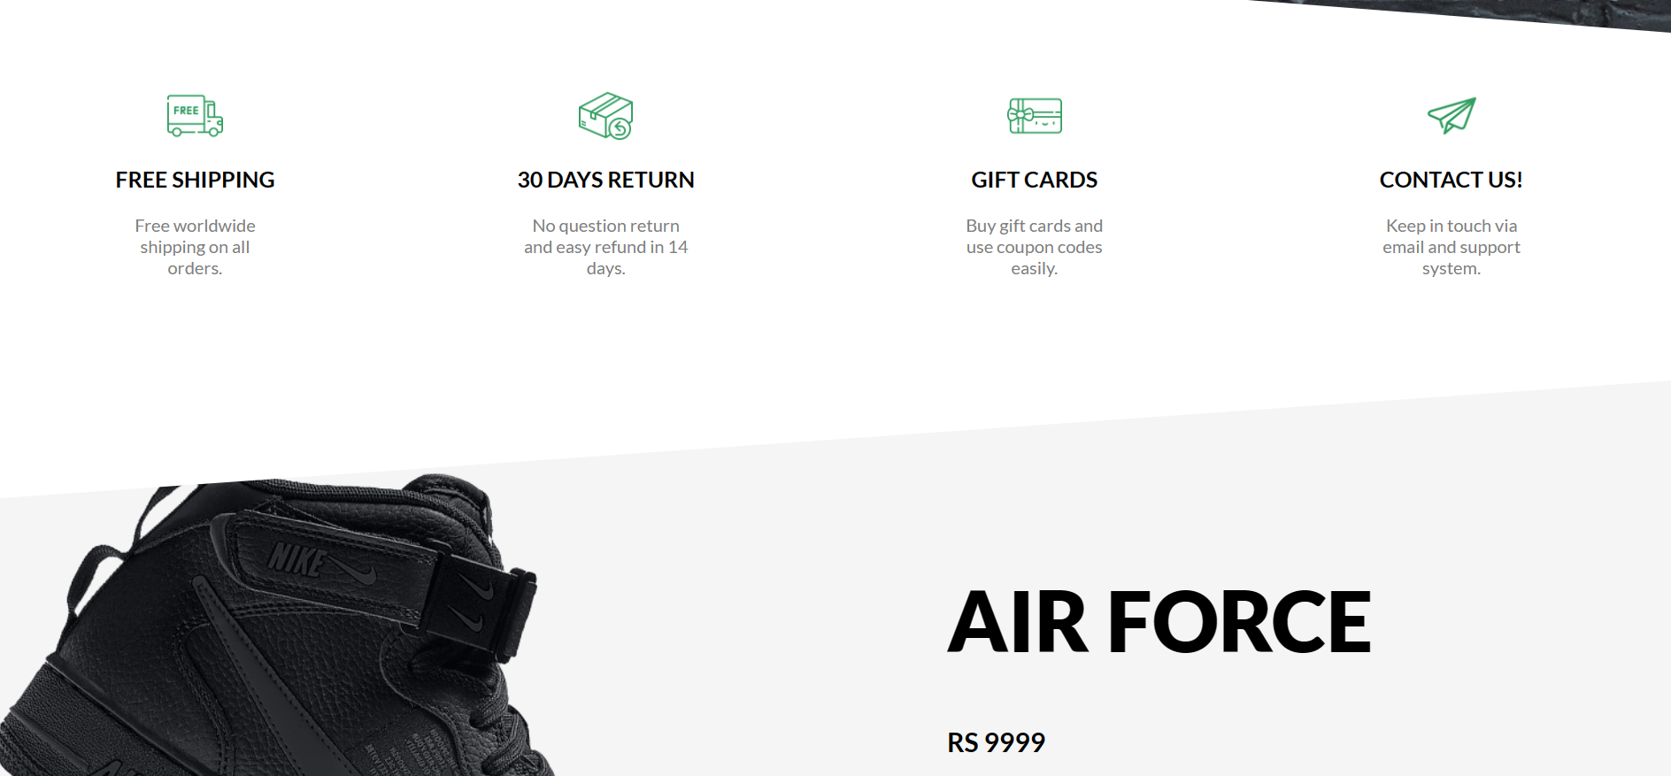

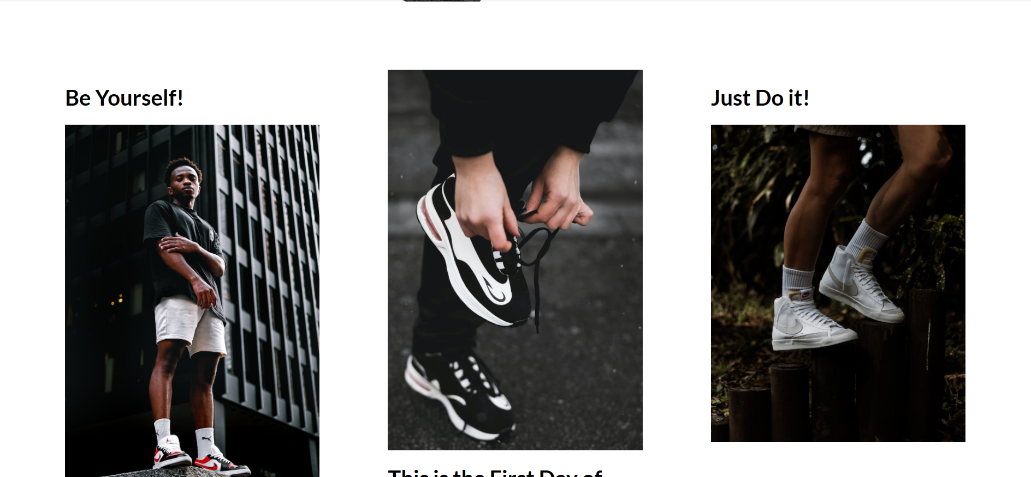

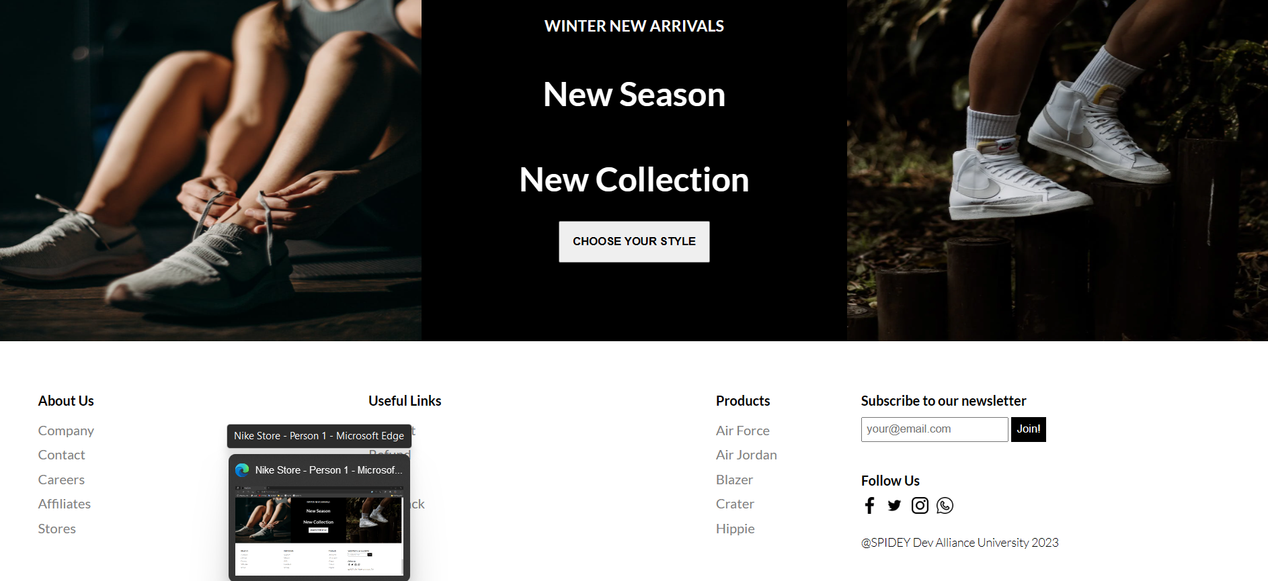

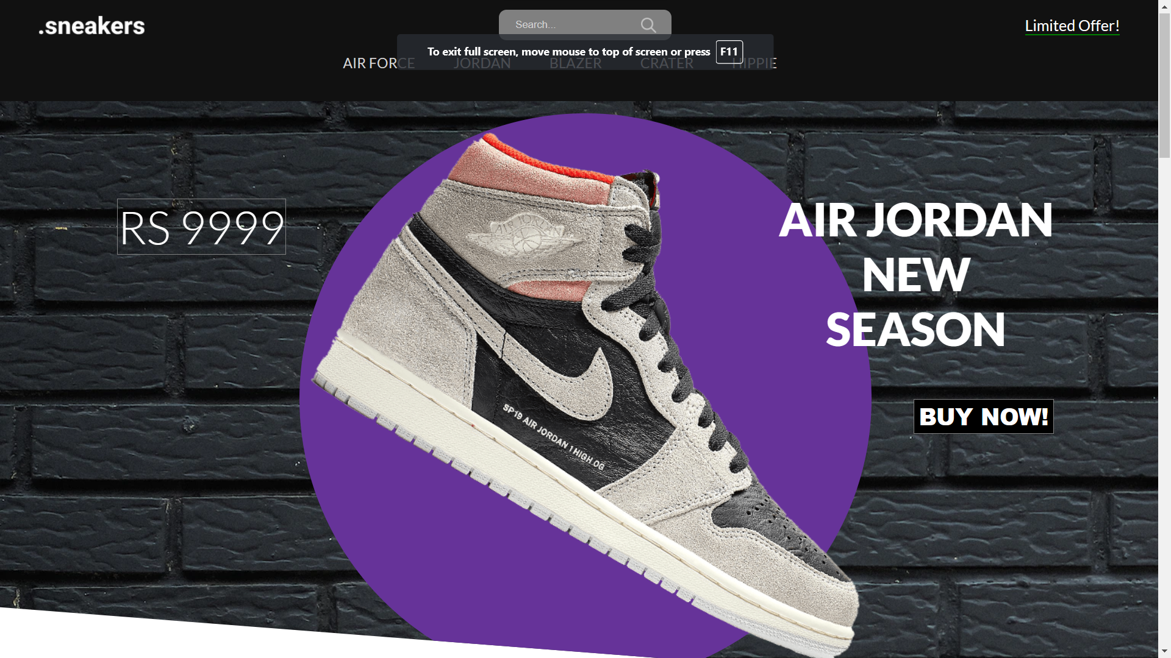

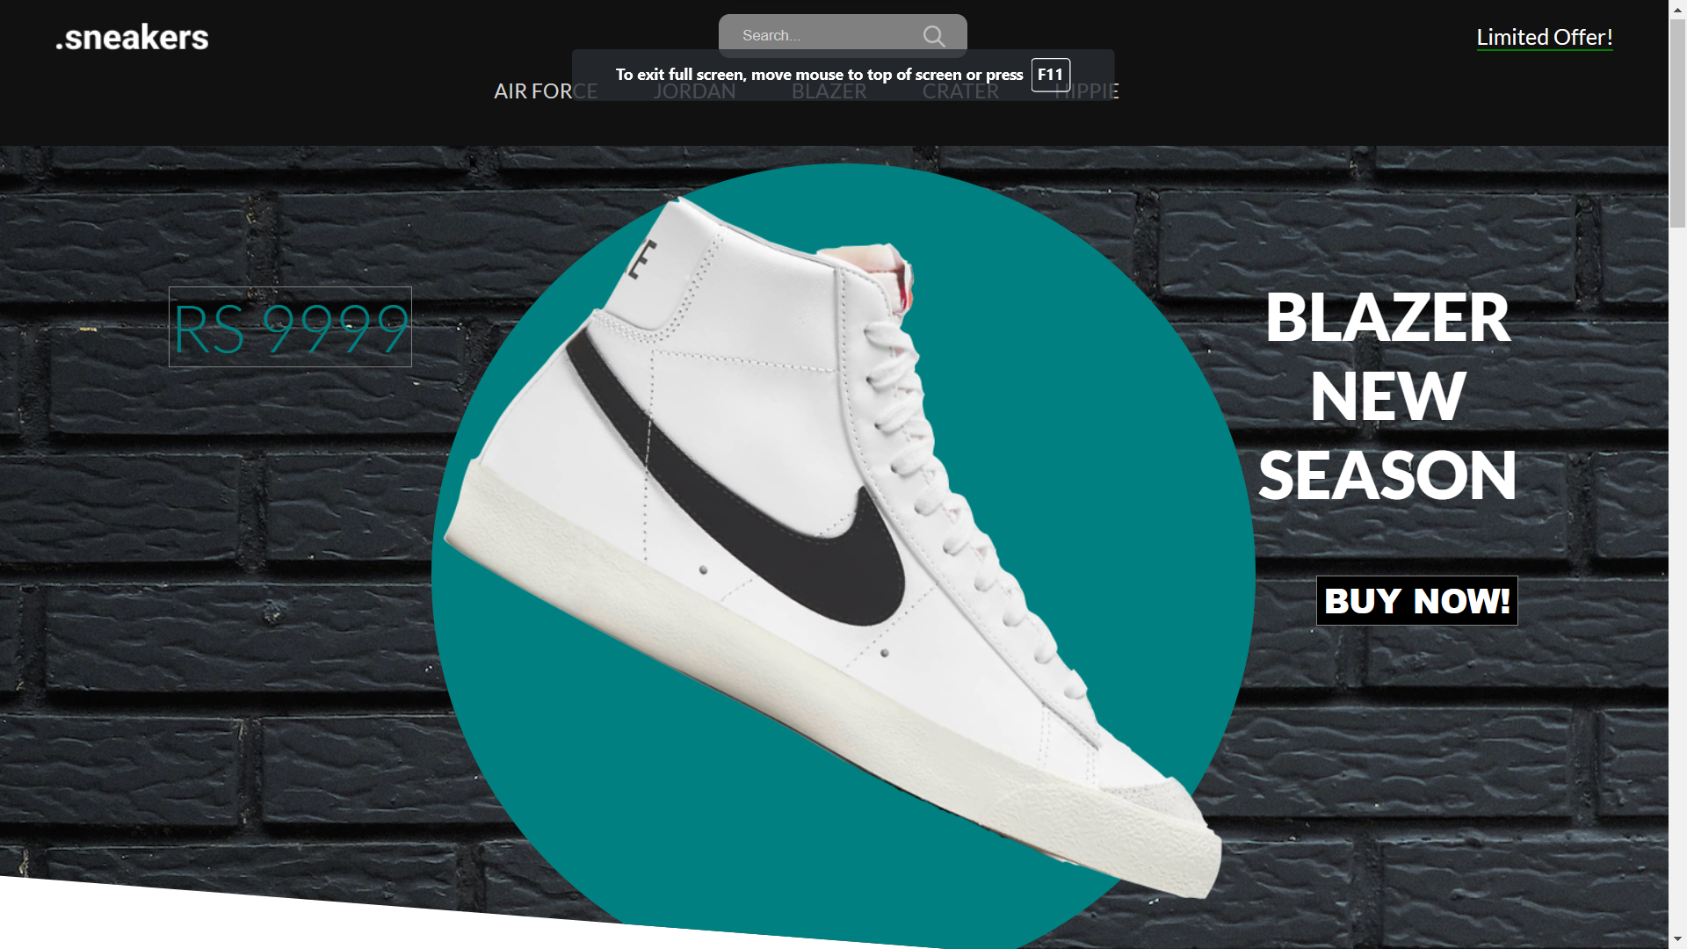

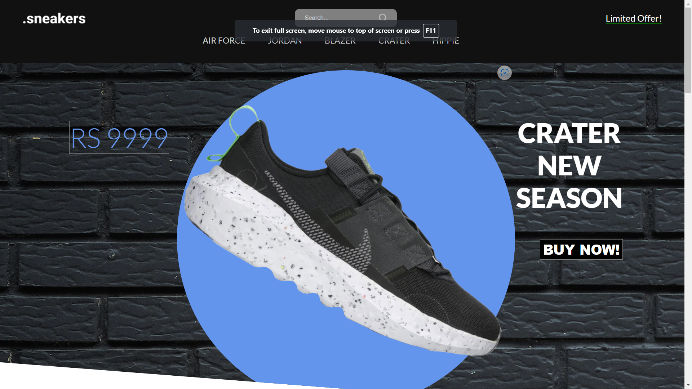

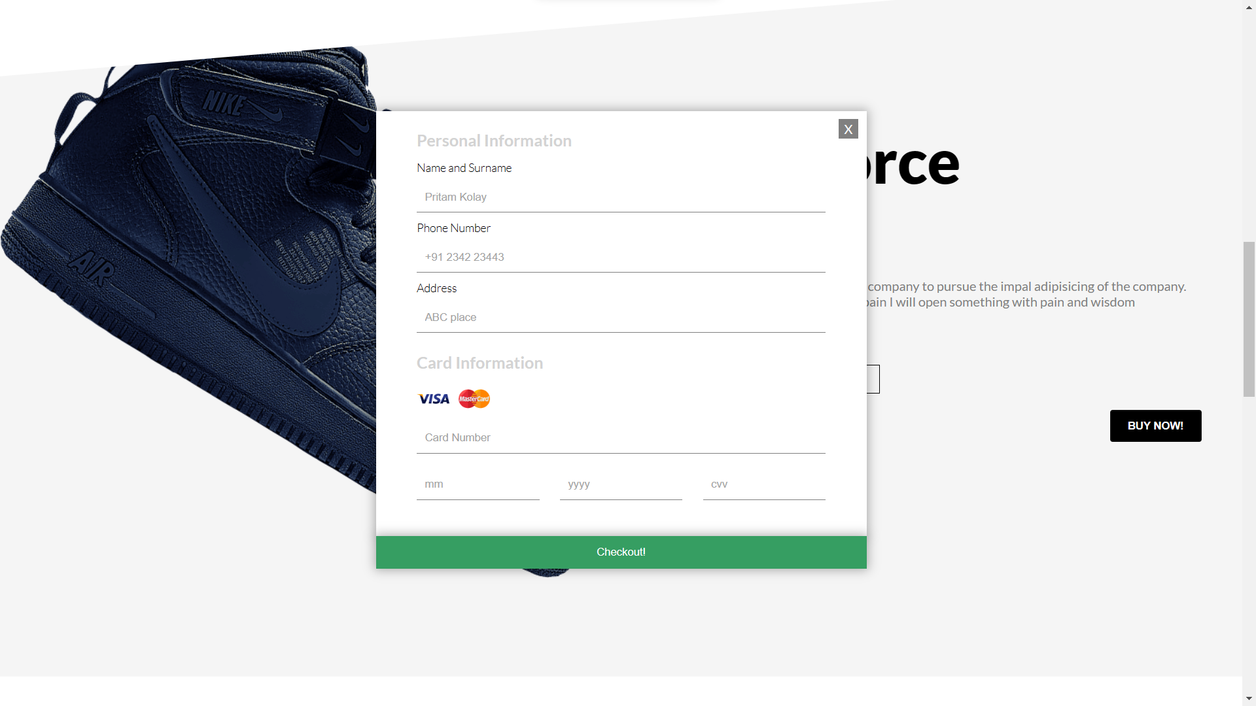

JAVA SCRIPT CODE FOR THE WEBSITE..........................................

const wrapper = document.querySelector(".sliderWrapper");

const menuItems = document.querySelectorAll(".menuItem");

const products = [

  {

    id: 1,

    title: "Air Force",

    price: 9999,

    colors: [

      {

        code: "black",

        img: "./img/air.png",

      },

      {

        code: "darkblue",

        img: "./img/air2.png",

      },

    ],

  },

  {

    id: 2,

    title: "Air Jordan",

    price: 9999,

    colors: [

      {

        code: "lightgray",

        img: "./img/jordan.png",

      },

      {

        code: "green",

        img: "./img/jordan2.png",

      },

    ],

  },

  {

    id: 3,

    title: "Blazer",

    price: 9999,

    colors: [

      {

        code: "lightgray",

        img: "./img/blazer.png",

      },

      {

        code: "green",

        img: "./img/blazer2.png",

      },

    ],

  },

  {

    id: 4,

    title: "Crater",

    price: 9999,

    colors: [

      {

        code: "black",

        img: "./img/crater.png",

      },

      {

        code: "lightgray",

        img: "./img/crater2.png",

      },

    ],

  },

  {

    id: 5,

    title: "Hippie",

    price: 9999,

    colors: [

      {

        code: "gray",

        img: "./img/hippie.png",

      },

      {

        code: "black",

        img: "./img/hippie2.png",

      },

    ],

  },

];

let choosenProduct = products[0];

const currentProductImg = document.querySelector(".productImg");

const currentProductTitle = document.querySelector(".productTitle");

const currentProductPrice = document.querySelector(".productPrice");

const currentProductColors = document.querySelectorAll(".color");

const currentProductSizes = document.querySelectorAll(".size");

menuItems.forEach((item, index) => {

  item.addEventListener("click", () => {

    //change the current slide

    wrapper.style.transform = `translateX(${-100 \* index}vw)`;

    //change the choosen product

    choosenProduct = products[index];

    //change texts of currentProduct

    currentProductTitle.textContent = choosenProduct.title;

    currentProductPrice.textContent = "RS"+" "+ choosenProduct.price;

    currentProductImg.src = choosenProduct.colors[0].img;

    //assing new colors

    currentProductColors.forEach((color, index) => {

      color.style.backgroundColor = choosenProduct.colors[index].code;

    });

  });

});

currentProductColors.forEach((color, index) => {

  color.addEventListener("click", () => {

    currentProductImg.src = choosenProduct.colors[index].img;

  });

});

currentProductSizes.forEach((size, index) => {

  size.addEventListener("click", () => {

    currentProductSizes.forEach((size) => {

      size.style.backgroundColor = "white";

      size.style.color = "black";

    });

    size.style.backgroundColor = "black";

    size.style.color = "white";

  });

});

const productButton = document.querySelector(".productButton");

const payment = document.querySelector(".payment");

const close = document.querySelector(".close");

productButton.addEventListener("click", () => {

  payment.style.display = "flex";

});

close.addEventListener("click", () => {

  payment.style.display = "none";

});